Bowling API Documentation:
- Create New Bowlers:
POST Request: http://localhost:8080/bowling/createBowler
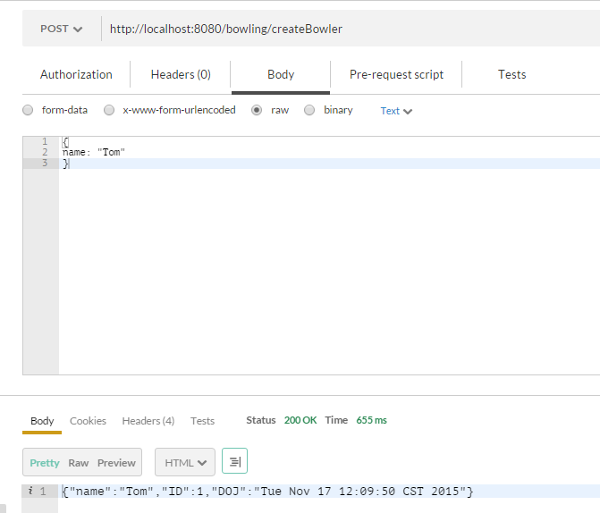

- Get all Bowlers:
GET Request: http://localhost:8080/bowling/Bowlers/getBowlers
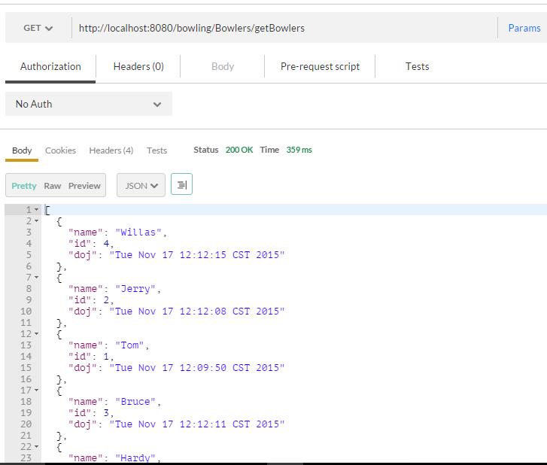

- Get Bowlers by ID:
GET Request: http://localhost:8080/bowling/Bowlers/getBowler/{bowlerID}
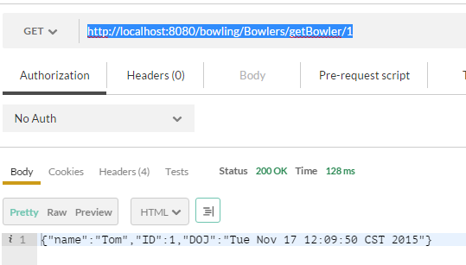
- Create League:
POST Request: http://localhost:8080/bowling/createLeague
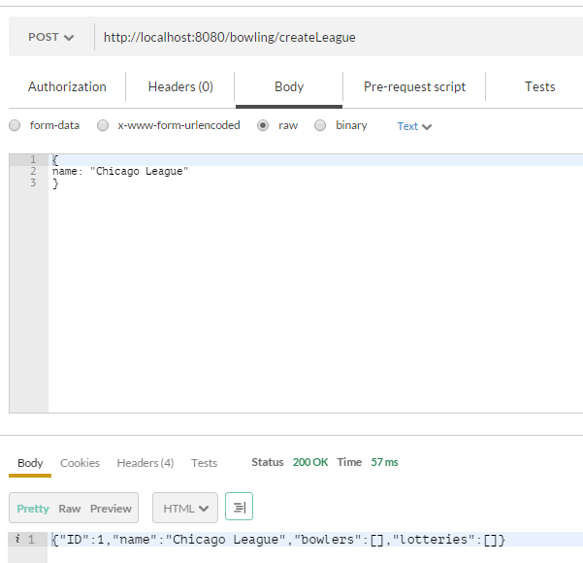

- Get all Leagues:
GET Request: http://localhost:8080/bowling/Leagues/getLeagues
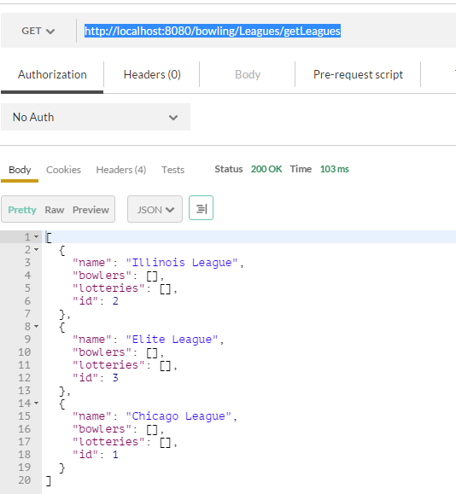

- Get League by ID:
GET Request: http://localhost:8080/bowling/Leagues/getLeague/{leagueID}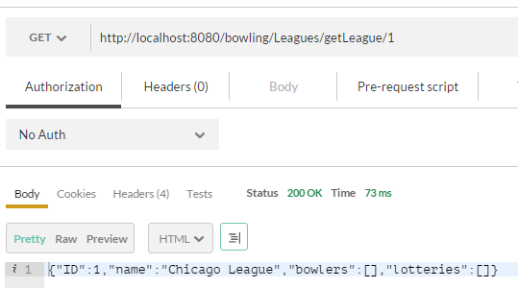

- Join League:
POST Request: http://localhost:8080/bowling/Leagues/joinLeague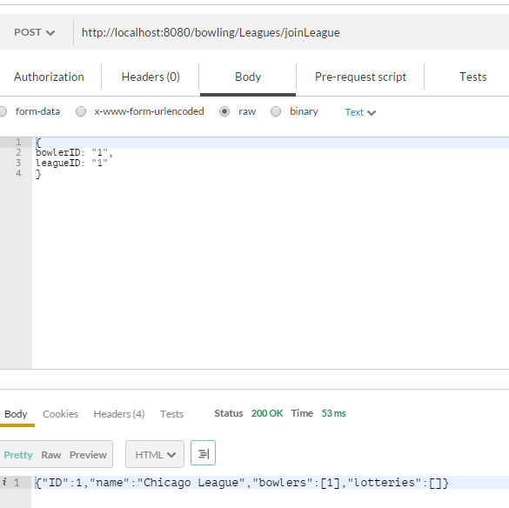
- Get Bowlers who Joined a League:
GET Request: http://localhost:8080/bowling/Leagues/{leagueID}/getBowlers

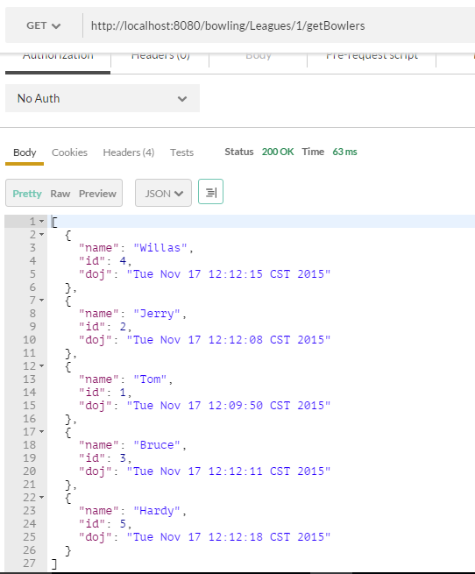

- Create Lottery:
POST Request: http://localhost:8080/bowling/createLottery
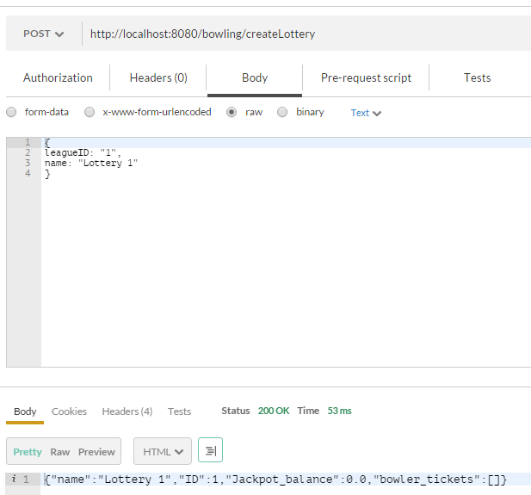

- Get all Lotteries for a given LeagueID:
GET Request: http://localhost:8080/bowling/Leagues/{leagueID}/getLotteries
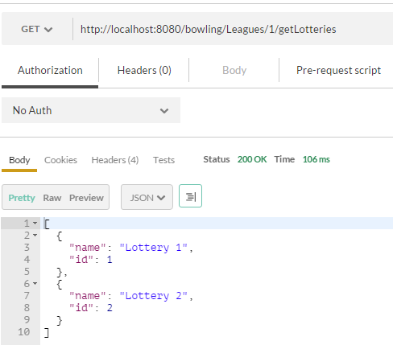

- Get a specific lottery based on Lottery ID and League ID:
GET Request: http://localhost:8080/bowling/Leagues/{leagueID}/getLottery/{lotteryID}
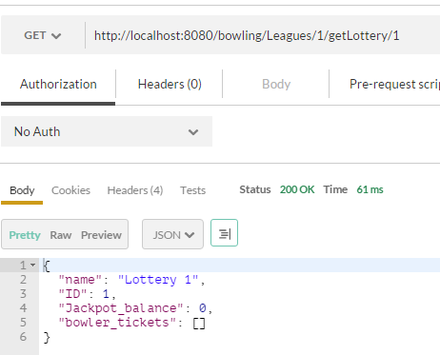

- Purchase Ticket:
POST Request: http://localhost:8080/bowling/purchaseTicket
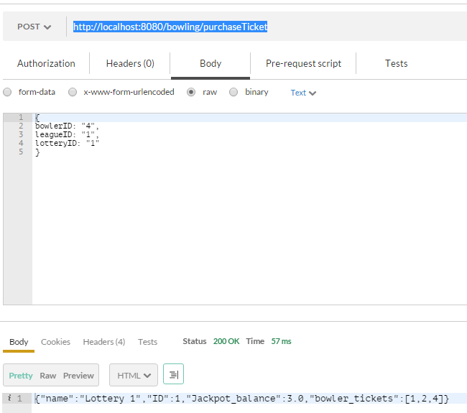

- Get all purchased Tickets for the current week based on Lottery ID and League ID:
GET Request: http://localhost:8080/bowling/Leagues/{leagueID}/Lottery/{lotteryID}/getPurchasedTickets
Output:
A HashMap object with Key as BowlerID and value as the number of tickets purchased by that bowler.
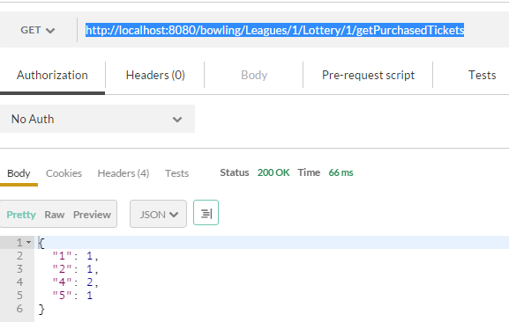

- Get purchased Ticket for a particular bowler ID based on Lottery ID and League ID:
GET Request: http://localhost:8080/bowling/Leagues/{leagueID}/Lottery/{lotteryID}/getPurchasedTicket/{BowlerID}
Output:
An integer value that provides the number of tickets bought by the given bowler.
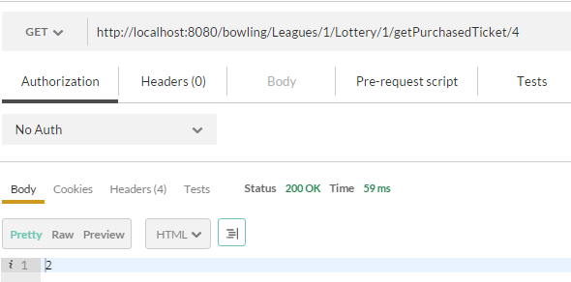

- Draw Winner for a specific lottery ID in a League:
GET Request: http://localhost:8080/bowling/Leagues/{leagueID}/Lottery/{lotteryID}/drawWinner
Output:
A Randomly selected Bowler from all the bowlers who bought ticket for the draw.
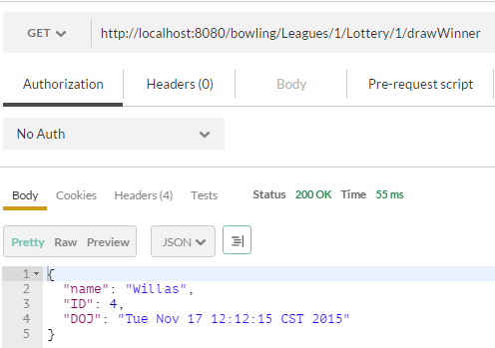

- Providing a chance to the winner of the draw to claim Jackpot by throwing a strike for the given lottery:
GET Request: http://localhost:8080/bowling/Leagues/{leagueID}/Lottery/{lotteryID}/throwStrike/{winnerID}
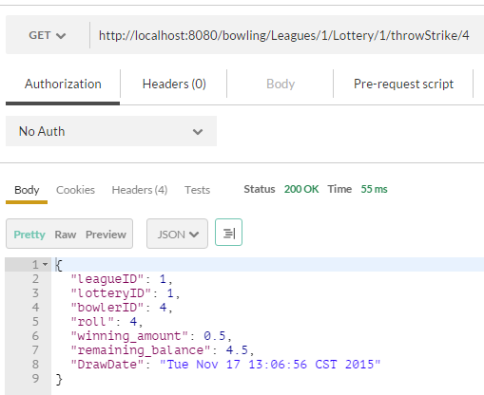
Note: After throwStrike request, balance gets carry forward for the next weeks draw. Also the tickets arraylist is cleared.
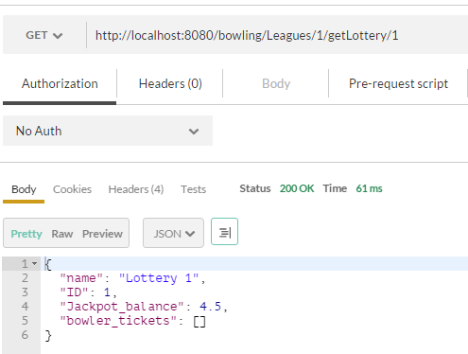
Data Storage:
All data is getting stored in HashSet as shown below. As serialization is not performed at start of the server the HashSet objects get reinitialized.
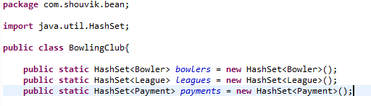
Things remaining:
- Fixing a day for the draw and error handling if DrawWinner request is called before that day.
- Allowing ticket sale till a day before the draw date. Freezing the ticket sale on the draw date.
- Displaying the Jackpot payout history data which is stored in the data model named payments.
- Serializing Datastore into a local file when the server stops to maintain persistence.

